Feynn Labs

Restaurant Menu Design based on Customer Test Behavior

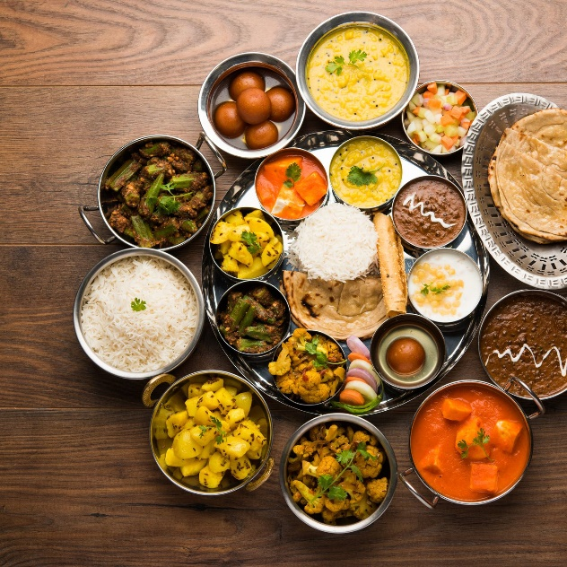 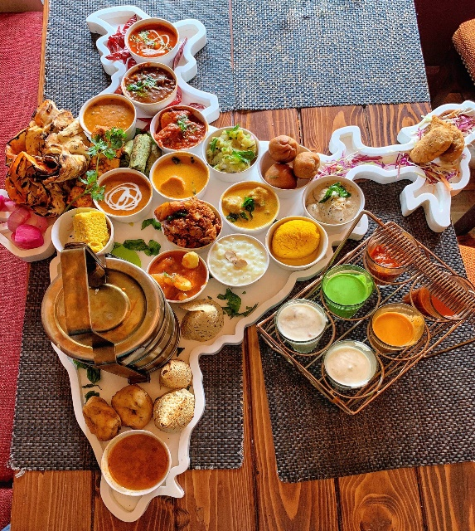

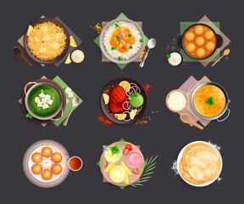

**Index**

Step 1

**Importing Libraries**

Step 2

**Reading data file into a python data frame**

Step 3

**Statistical Summary**

Step 4

**Checking for null values**

Step 5

**Dumping unwanted columns**

Step 6

**Exploring for insights at the State level**

Step 7

**Exploring for insights at the District level**

Step 8

**Gathering Insights for few selected states ,Let's dive deep into these**

**states before selecting one for our first market**

Step 9

**Recommendations based on our EDA**

**PROBLEM STATEMENT:-**  
Identifying the trend in the sales of food items. So it helps the restaurant to predict the day-by-day food master menu.

**Why this field?**

A lot of food is being wasted across the country. Restaurants plan its menu according to the test behavior pattern of customers. Restaurants can get max profit with minimum utilization of resources.

All previously bill data is with restaurants. I used that data to build one master menu for a restaurant

Many solutions are being suggested to solve this problem. AI is one among them and I strongly believe that AI can contribute a lot to this field. AI can not only solve problems in this field but it can also optimize the techniques that are being used for decades.

**BUSINESS NEED ASSESSMENT:**-

* Many local food chains know that their sales follow a certain trend and  
  know what sort of groceries they need to buy and store during which  
  season Weekday and weekends But they do not know it accurately and most of the time they miss one thing or the other.
* Customers are also satisfied with the menu and their test matches with the menu card.
* Customer satisfaction is more important.
* This analysis will cut down their costs and reduce the wastage of food.
* Helps to Grow the restaurant

**TARGET SPECIFICATIONS:-**

* Customer satisfaction.
* Reduced the cost of food.
* On the basis of popular dish trained they can hire a cook.
* Help treduceed the cost of food and focused more on amenities.



Data sources

1. Restaurants food consumption

Data collection was the hard part of the project. Since the dataset wasn’t given readily, we had to explore and find datasets ourselves from various sites like the Indian census website. However, I can find a few datasets on the above sites and Kaggle. I concluded that search because every time we researched we only concluded that this type of data is not a freely available and the most efficient way of getting this type of data is to survey customers directly

Data Pre-processing and Exploratory Data Analysis

Exploratory Data Analysis (EDA) is an approach/philosophy for data analysis that employs a variety of techniques (mostly graphical) to

1. maximize insight into a data set;

2. uncover underlying structure;

3. extract important variables;

4. detect outliers and anomalies;

5. test underlying assumptions;

6. develop parsimonious models; and

7. determine optimal factor settings.

The EDA approach is precisely that--an approach--not a set of techniques, but an attitude/philosophy about how a data analysis should be carried out.

Most EDA techniques are graphical in nature with a few quantitative techniques. The reason for the heavy reliance on graphics is that by its very nature the main role of EDA is to open-mindedly explore, and graphics give the analysts unparalleled power to do so, enticing the data to reveal its structural secrets, and being always ready to gain some new, often unsuspected, insight into the data. In combination with the natural pattern-recognition capabilities that we all possess, graphics provide, of course, unparalleled power to carry this out.

We have carried out an extensive exploration of the available data to get as much understanding of the patterns as possible. For this, we have used libraries like Numpy, Pandas, matplotlib, and plotly. Express.

Firstly we had to check for any missing values from the columns and also do a thorough check on if data values are consistent or not which was our main focus as analysis of inconsistent data is as good as garbage. Below are the steps that were taken to carry out EDA as detailed as possible by us.

Data shape :-

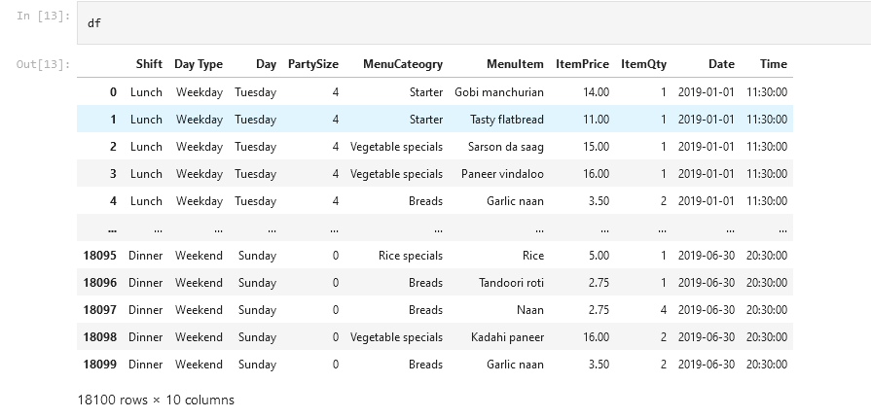

It contains the data noise .converted well stretchered data .

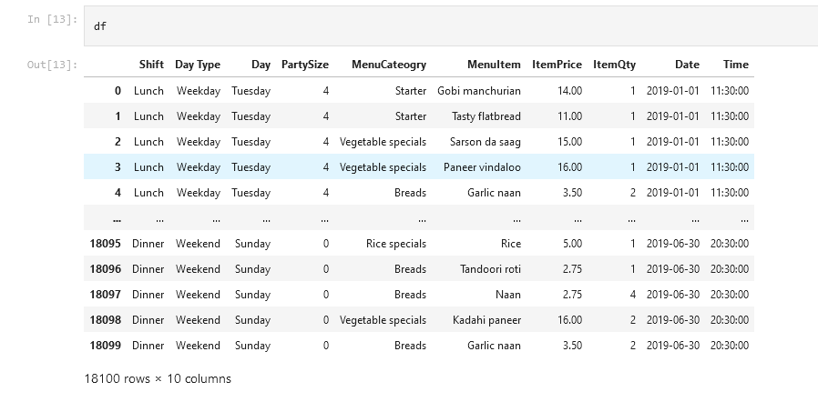

**Benchmarking**

Generally, Benchmarking involves comparing project processes and performance metrics to either industry best standards and practices or successful completed projects. For this there is a need to continuously search for implementation of better techniques which lead to better results or outputs.

Restaurant and the restaurant customer should be satisfied with minimum cost and best test respectively .

Every time restaurant customers feedback matters for this process makes successful.

**APPLICABLE REGULATIONS:**

* Restaurant customer data will be secure
* Customers feed back data will be secure
* Model is applicable for one region of the customer
* Region-wise change the test so it will help big chain restaurants
* It will help for delivery paternar also like swigi, zomato

**BUSINESS OPPORTUNITIES**

The target customers here are mainly restaurant chains and Big Hotels that have a good number of customers.

The customer behavior and test depends upon the time. Project give one master menu for the restaurant. If the model is successfully implemented for the previously mentioned targets, the model can be expanded for the Master menu that is in multiple cities.

In these time constraints like week-ends, weekdays are there.

**CONCEPT DEVELOPMENT: -**

We must first understand the environment before we start working on a model and the type of food, the people in that region like and what are the traditions there. After gaining sufficient knowledge about the environment we have to start collecting data. After collecting the data, we have to perform EDA which is used to identify patterns in the dataset and it will help us zone in on the areas that are leaking money. Visualization will help a lot here. Once we have found the trend and outliers, the next step is to use the basic regression models and time-series models , in which we will fit our training dataset and see what sort of results we will be getting.

**CODE IMPLEMENTATION:-**

**Dashboard :-**

<https://public.tableau.com/views/RestaurantMenuDesignbasedonCustomerTestBehavior/menu_categorycontributioninItemQuantity?:language=en-US&:display_count=n&:origin=viz_share_link>